# FILL IN THE BLANKS

1. Elements in a tuple can be oftype.



1. Tuples are indexed by an



1. Tuples are  you cannot update or edit the tuples.
2. function is used to converts a sequence data type into tuple.
3. Like lists, Dictionaries arewhich means they can be changed.



1. A Python dictionary is a  of unique keys to values. It is a collection of key-value pairs.
2. The association of a key and a value is called a
3. To create a dictionary, key-value pairs are separated by



1. In key-value pair, each key is separated from its value by a

10.function returns the keys of the dictionary.



# ANSWERS TO FILL IN THE BLANKS

1. dissimilar 2. integer 3. immutable

4. tuple() 5. mutable 6. mapping

7. key-value pair 8. comma 9. colon (:)

10. key()

## SOLVED QUESTIONS

1. What is a tuple?

Ans. A tuple is an immutable sequence of values which can be of any type and they are indexed by an integer.

1. What are the differences between lists and tuples?

Ans. The differences between tuples and lists are that tuples cannot be changed unlike lists and tuples use parentheses, whereas lists use square brackets.

1. What is the similarity between strings and tuples?

Ans. Tuples are immutable like strings, you cannot update or edit a tuple. To change it, you have to create a new one just like strings.

1. Tuples can be used as keys in Python dictionaries. True or False?

Ans. True

1. Tuple is an ordered immutable sequence of objects. Justify your answer. 

Ans• Tuple is an ordered sequence of objects as each element is accessed by its index and it is immutable as you cannot change the values in place. You cannot update or edit the tuple.

1. What is a dictionary?

Ans• A Python dictionary is a mapping of unique keys to values. It is a collection of key-value pairs. Dictionaries are mutable which means they can be changed.

189

1. What are the differences between lists and dictionary?

Ans. The differences between dictionary and lists are that in lists, elements are enclosed within square whereas in dictionary, key-value pairs are enclosed within curly braces. In dictionary, index

1. Can list be used as a key to dictionary? State yes or no. Also justify. Ans. Lists cannot be used as key to dictionary as they are mutable.
2. Write different ways of creating tuples with one Item and print the same.

Ans. (a) tupl—5, print (tupl)



print (tupl)

(c) tupl=tuple ( (10, ) ) print (tupl)

1. 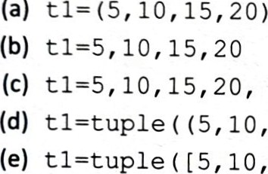Write a statement to add a single item in a tuple.

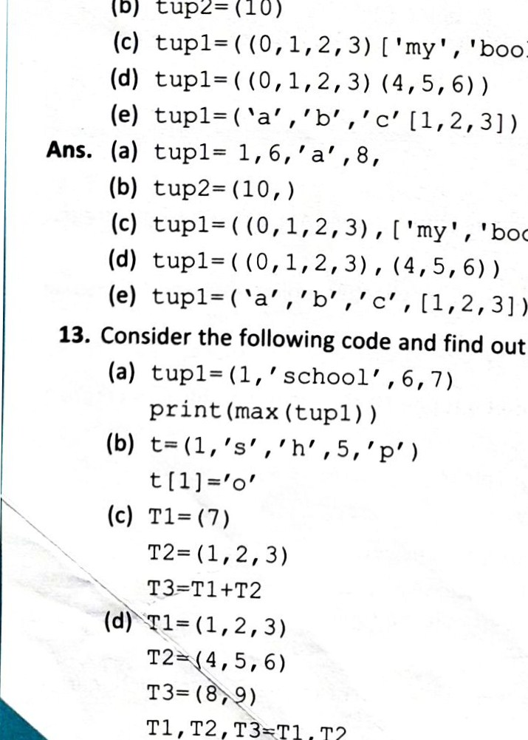

(a)

tupl=

1,

6,

(b)

tup2=

(10)

out

the

error:

Tl,T2

### Ans. (10, 20, 30, 40) t=t+ (60, )

11. Write different ways of creating tuples with the following numbers.

Ans. (a)

(5, 10, 15, 20) )

### 10, 15, 20])

12. Following are the statements for creating tuples. Find the errors in the statements and rewrite the same

a, 8,

'book' J)

['my', 'book'] )

, 6, 7)

#### 190

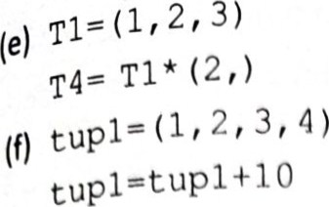

print (tupl)

(g) tuple ) 0 3 '

print (tupl)



a, b, eat 1

Ans. (a) max() will work only if elements in a tuple are of same data type.

1. Tuples are immutable, we cannot change the value of any element,
2. operator joins two tuples, here (7) is 'Int', so will give error,
3. For tuple assignment, left hand side and right hand side elements should be the same, T3 is not there on right hand side.
4. operator requires a tuple and an integer as operands.
5. The '+' operator simply performs a concatenation with tuples. Here 10 is an integer.
6. operator requires a tuple and an integer as operands. Here '3' is a string.
7. For unpacking a tuple, number of variables on the left side of assignment and the numberofelements in the tuple must match.
8. Find errors, underline them and rewrite the same after correcting the following code:

dl=dict [ ]

n=input ("Enter number of entries : ") while :

a=input ( "Enter name : " ) b=input ( "Enter age : " ) dl (a) =b

1 = dl . key [ ] for i in l:

print (i, ' \ t', ' dl [i] ' )

Ans. dl=dict ( )

n=int (input ("Enter number of entries : ") ) while :

a—input ( "Enter name : " ) b=input ("Enter age : " ) dl t a] =b

I = dl.keys ( ) for i in 1:

|  |  |
| --- | --- |
| dl |  |

print (i, ' \ t' ,

1. Write the output of the following codes:



>>>dl . items ( )

>>>dl . keys ( )

>>>dl . values ( ) 191

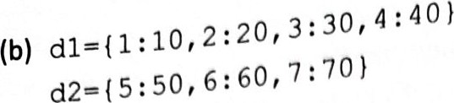dl . update (d2)

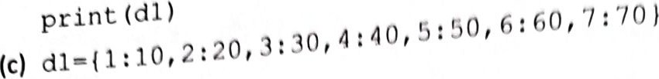

del dl ( 3 ) 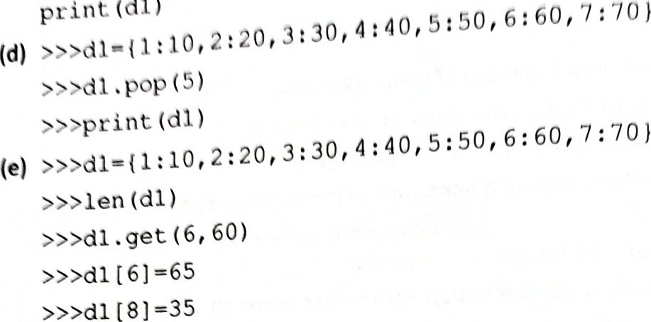print (dl)

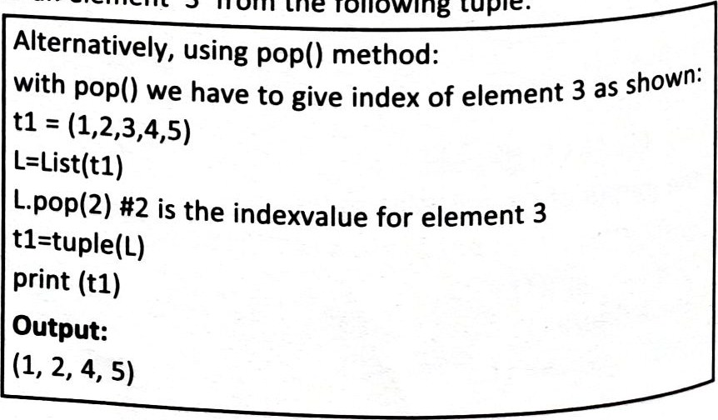>>>print (dl)

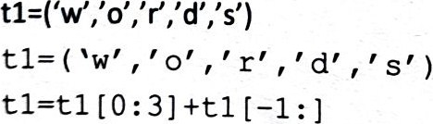

Ans.

>>>dl . clear ( )

>>>print (dl )

Ans. (a) dict_items 10), (2, 20), (3, 30), (4, 40), (5, 50)] dict_keys [1, 2, 3, 4, 5] dict_values [10, 20, 30, 40, 50]

* 1. {1: 10, 2: 20, 3: 30, 4: 40, 5: 50, 6: 60, 7: 70} 
  2. {1: 10, 2: 20, 4: 40, 5: 50, 6: 60, 7: 70}
  3. 50

{1: 10, 2: 20, 3: 30, 4: 40, 6: 60, 7: 70}

60

{1: 10, 2: 20, 3: 30, 4: 40, 5: 50, 6: 65, 7: 70, 8: 35}

1. Write a Python program to display all the elements of the following tuple except 'd'

print (t 1) Output:

1. Write a Python program to remove an element '3' from the following tuple:

Ans.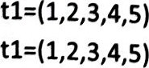

L=list(tl) L.remove(3) t1=tuple(L) print (tl) Output:

#### 192

18. 

consider the above tuple ttl' and answer the following questions :

|  |  |  |
| --- | --- | --- |
| (a) len (t 1) (b)  (c)     (d) |  |  |
| (e) t 1 . index (20) | t: 1 Index (30) |  |
| (g) t 1. index (30, 7, 10) (h) | El . count (30) any (t 1) |  |
| Ans. (a) 11 (b) | (10, 20, 'book' , 30, 9.5, | item ) |
| (c) (30, 9. 5, t item' , [12, 13] ) (d) | ( 'item' , [12, 13] (3, 4) ,  3 | 30, 5, 30) |
| (h) | 3 |  |

 True

19. ("TEA 10)

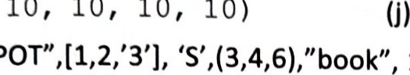

(10,

10,

10,

10,

10)

|  |  |  |  |
| --- | --- | --- | --- |
| Based on tuple Tl above, write the output for the following expressions: | |  |  |
| (a) TIC 1] [1] (b) 10 in Tl  (c) 50 not in TI (d) Tl [4] [3]  (e) TIC 1] [2]   Tl [-5:-3] +TI [3]  (h)  Ans. (a) 2 (b)  True (c) True (d) |  |
| (e) '333'  (g) 'TEA POTS'   1. Write the output of the following statements:    1. >>> tuple ("book") (b) >>> tuple   (c) >>> ("Riya" , ) *3 (d) (10, 12, 73, 34)  (e) (40, 20, 100, 60)  Ans. (a) ( 'b ' , , o  (c) ('Riya , , 'Riya ' ) (d) 73   1. Compare the tuples and write the output:    1. >>>tupl= (1, 2, 3) | 3, | 4, | 6) |



>>>tup1==tup2

1. >>> 'VAIBHAV' , 'MINI', 'RAGHAV')

>>> 'Ravi' , 'Maia' , 'Æ•IAN' 'SAKSHI' )

>>> tupl<tup2

1. (10, 20, 30, 40, 50)

(4, 5, 10, 20, 30, 40, 50)

>>>tup2>tup1

1. >>>tupl ! =tup2

Ans. (a) True

1. True
2. False
3. True

22.

(100, 200, 300, 400)

Write the output of the following:

y»t3, t2, €2, €3 »»print(tl) y»print (€2)

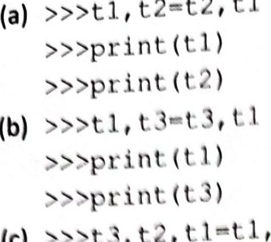

t

I

t2—t2,

(c)



### Ans. (a) (10, 20, 30, 40)



(b) (100, 200, 300, 400)

(10, 20, 30, 40)

### (c) (10, 20, 30, 40)



(100, 200, 300, 400)

23. Write a Python program to input 'n' names and phone numbers to store it in a dictionary and printte phone number of a particular name.

phone=dict ( )

n=int (input ("Enter number of entries : while :

a—input ("Enter Name : " ) b=input ("Enter Phone no: " ) phone [a] =b



1 = phone. keys ( ) x=input ("Enter name to be searched: ") for i in 1: if i==x:

print (x, phone no is: v' , phone break else:

print (x, " does not exist") Qns. Output:

Enter nurnber of entries: 4

Enter Name : Riya

Enter Phone no: 9999 Enter Name : Aman



Enter Name : Pulkit Enter Phone no: 5555 Enter Name: Ziya

Enter Phone no: 2222

Enter name to be searched Aman

